**COMPONENT CREATION USING REACT**

**Name:** Papana Anusha

**Email:** papanaanusha00@gmail.com

**Phone No:** 6305991272

**Roll No:** 20NN1A0593(CSE)

**College Name:** Vignan’s Nirula Institute of Technology and Science for Women

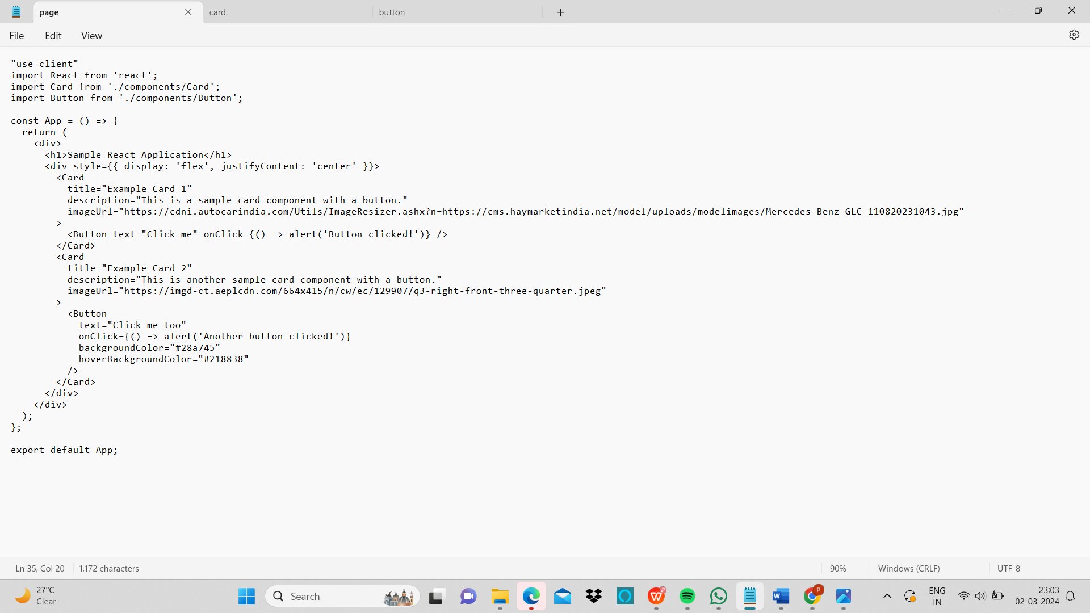

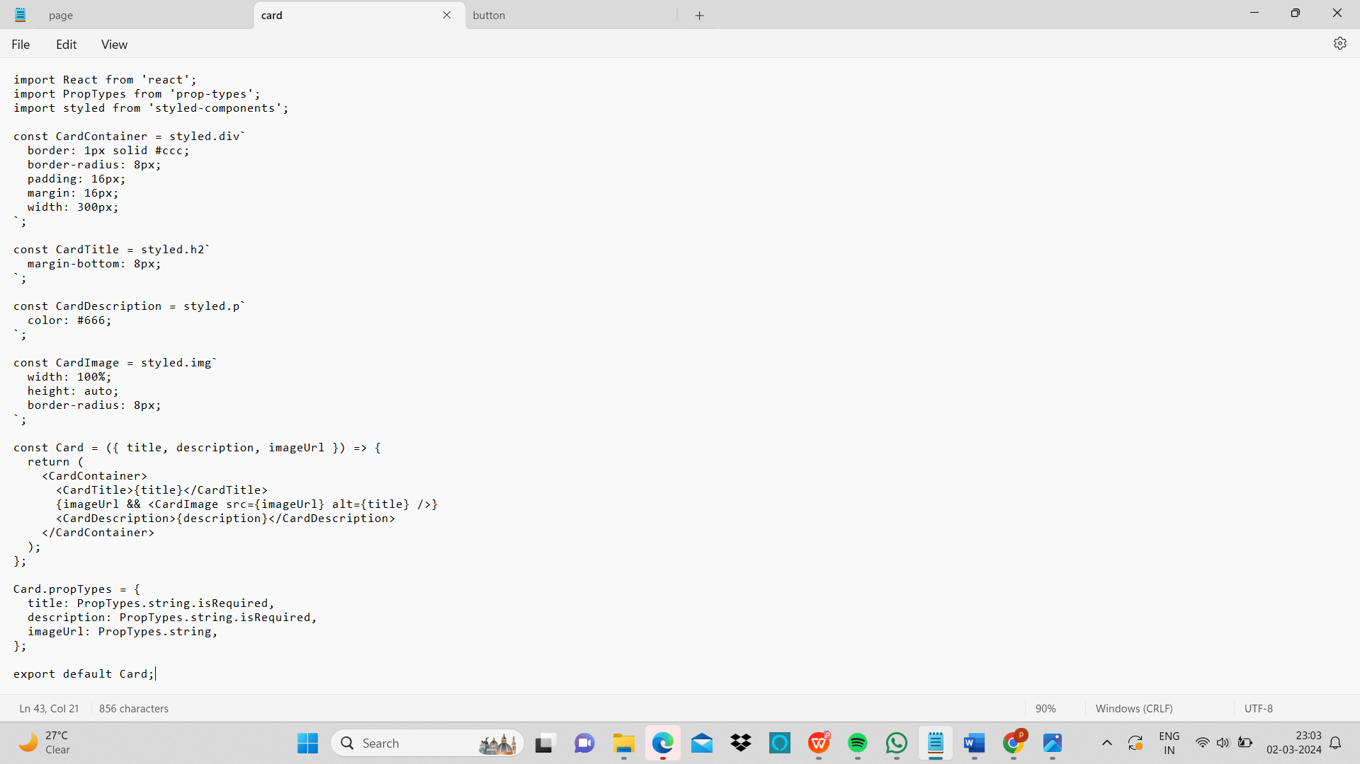

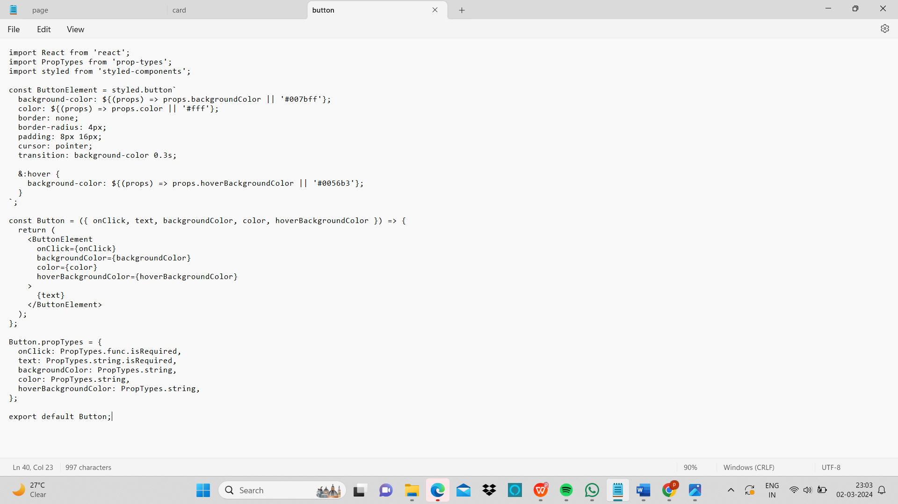

Output:

